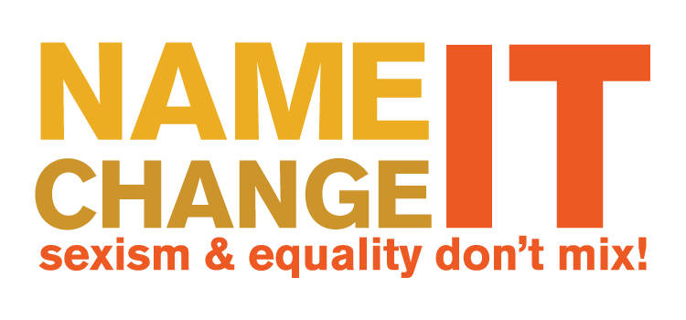

The 2012 Name It. Change It. Awards For Most Sexist Media Coverage of Women Candidates and Politicians

- Most Sexist Interview Question: Chicago Sun-Times/ reporters Dave McKinney, Fran Spielman and Natasha Korecki for Lisa Madigan interview
- Most Sexist Debate Question: YNN “Capital Tonight” anchor Liz Benjamin/ New York Senate Debate
- Most Sexist Insult: Fox News’ “The Five” co-hosts Greg Gutfeld and Kimberly Guilfoyle
- Most Sexist Columnist: Howie Carr of Boston Herald
- Award For Creating Sexist Standards For Women in Politics: Huffington Post Politics: Ethan Klapper; Huffington Post Style: Ellie Krupnick, Jessica Misener, Fashion Whip Columnists Lauren Rothman and Christina Wilkie

Most Sexist Interview Question:
Chicago Sun-Times
Dave McKinney, Fran Spielman and Natasha Korecki for Lisa Madigan interview



Usually newspaper readers don’t get to hear the questions reporters ask politicians. We just get to read the responses. Which is why when three reporters for the Chicago Sun-Times made their sexist questions to Illinois Attorney General Lisa Madigan very obvious in their article, we were grateful – grateful everyone got to see this sexist assumption being pushed by the Chicago Sun-Times.

Chicago Sun-Times reporters Dave McKinney, Fran Spielman and Natasha Korecki asked Illinois Attorney General Lisa Madigan whether she might run for governor in 2014. Fair question. But then Madigan was asked three times whether she could serve as governor and still raise her two kids. Apparently her first answer to the reporters: “Wow. Does anybody ever ask that question?” wasn’t good enough because they pressed her two more times to answer the question, even going as far as to “remind” her that being governor is a different job than being attorney general.

Chicago Sun-Times, do you really think women can’t be parents and politicians? It’s funny how no one ever seems to ask men with young children how they will handle their parental duties.

For not only asking such an obviously sexist question but then putting it in your article, the Chicago Sun-Times wins our Most Sexist Interview Question Award!

Most Sexist Debate Question
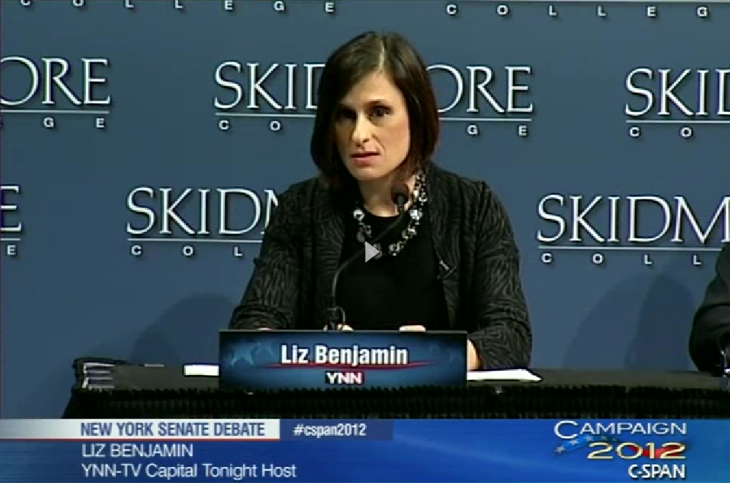
YNN “Capital Tonight” anchor Liz Benjamin/ New York Senate Debate

In most elections if there is a debate, it’s usually a member of the media who gets to ask the candidates questions. They are entrusted to ask candidates about issues affecting the voters. Which is why it is all the more disturbing when a TV anchor is given this important responsibility and she uses it to ask a very embarrassing and sexually laden question of two women who were running for office.

During the only televised debate for the New York Senate seat, moderator Liz Benjamin, the anchor of “Capital Tonight” on YNN, asked candidates Kirsten Gillibrand and Wendy Long whether they had read the sexually graphic novel “Fifty Shades of Grey” by British author E.L. James. One wonders if two men had been vying for the Senate seat would she would have asked if they had subscriptions to Playboy? Would Benjamin have asked about the book if either candidate was a man?

For wasting a precious opportunity to ask the candidates a question about issues that could affect voters and for inappropriately turning a political debate into a forum for S&M-themed reading material, YNN “Capital Tonight” anchor Liz Benjamin wins our Most Sexist Debate Question award!

Most Sexist Insult


Fox News’ “The Five” co-hosts Greg Gutfeld and Kimberly Guilfoyle

Cable news anchors are supposed to be adults, not children on the playground. It’s perfectly fine to disagree with a politician. However it’s totally sexist to basically call her “ugly” on national television. But two co-hosts of Fox News’ “The Five” apparently think the best way to show you disagree with a female politician is to denigrate her looks.

On one show co-host Greg Gutfeld referred to Debbie Wasserman Schultz as “Frizzilla” and a “wooly windbag” because apparently he can’t rebut her position without referring to her looks. Then on another episode of “The Five” co-host Kimberly Guilfoyle, after speculating about what a great “bad” pair Debbie Wasserman Schultz and Congressman Allen West would make, added her own gratuitous insult saying, "Yeah, if you're into that Frizzilla thing. I gave up perms a long time ago."

If given the opportunity to co-host a nationally televised program you can raise the level of debate and treat women politicians fairly even if you disagree with their politics. Or you can turn into a five-year-old and call them ugly. It’s clear which direction Fox News’ “The Five” wants to go and for that they win our Most Sexist Insult Award!

Award For Most Sexist Columnist:
Howie Carr


It’s been said to whom much is given, much is expected. Howie Carr has not one but two media platforms, a regular column with the Boston Herald newspaper and a radio show on WRKO. Back in February 2012 Howie Carr came up with what he thought was a great nickname for Elizabeth Warren, “Granny.” Throughout the rest of the 2012 election season when Howie referred to Elizabeth Warren it was often just “Granny.” He often didn’t even refer to her by last name. He also called her many other names, like “Pocahontas” and used plenty of offensive racial tropes, which included playing the "Tomahawk Chop" anthem on his radio show.

Howie Carr wins our Award For Most Sexist Columnist for filling up the Boston media market with sexist nicknames through both his radio show and newspaper column.

Award For Creating Sexist Standards For Women in Politics
Ethan Klapper, Huffington Post Politics Social Media Editor
Ellie Krupnick, Huffington Post Style Associate Editor
Jessica Misener, Huffington Post Style News Editor
Lauren Rothman, Fashion Whip Columnist
Christina Wilkie, Fashion Whip Columnist

While fashion coverage of Michele Bachmann, Hillary Clinton, and more recently Nancy Pelosi, is putting the focus on the wrong parts of a women’s politics, one of most sexist media incidents of the year was posted by The Huffington Post Politics Social Media Editor Ethan Klapper. The Huffington Post Politics section invited readers to tweet captions for an AP picture of Secretary of State Hillary Clinton dancing in South Africa. The problem is the suggested captions included several blow jobs jokes curated together in a slideshow titled #ClintonCaptionContest.
When a woman runs for president I’m sure the first thing everyone wants to know is how do her clothes stack up, right? Wrong! But Huffington Post Style News Editor Jessica Misener, Associate Editor Ellie Krupnick and Fashion Whip Columnists Lauren Rothman and Christina Wilkie kept up a steady stream of fashion critiques of Michele Bachmann’s outfits up until she dropped out of the presidential race. Sure there was an odd post here or there about Herman Cain’s suits or Rick Perry’s watch, but we knew after every single debate we could count on an article in the Huffington Post Style section to breathlessly describe what Bachmann wore or what her make-up looked like, as if that’s something that matters.

Even after she dropped out of the presidential race Fashion Whip columnists Lauren Rothman and Christina Wilkie felt the need to wrap up all that pointless fashion coverage with a truly inane, and mean-spirited, video. It’s Rothman who says this sexist gem with a smile, “When her [Bachmann’s] numbers went down, she should have brought down her neckline. Might have helped.”

But with Bachmann out of the presidential race, The Huffington Post Style team then had to find a new person to turn their attention to for a fashion critique and that was Secretary of State Hillary Clinton. Of course there was endless talk about her hair “scrunchies” because that’s what’s important about being fourth in the line of succession for President of the United States.

The award goes to Huffington Post Politics Social Media Editor Ethan Klapper, Huffington Post Style editors Ellie Krupnick, Jessica Misener, and Fashion Whip columnists Lauren Rothman and Christina Wilkie, for putting women’s appearances ahead of their job duties -- and an incredibly sexist slideshow -- we give you an Award For Creating Sexist Standards For Women in Politics.


The Name It. Change It. Media Awards for Most Sexist Coverage of Women Candidates and Politicians are a product of The Women’s Media Center‘s work to monitor all platforms of media for sexist coverage of women candidates and public leaders. As part of our organization mission to make women visible and powerful in the media, The Women’s Media Center conducts media research, monitoring, and activism to hold media accountable for sexist content, biased coverage, and disparities in women’s representation as news sources and newsroom decision makers.

